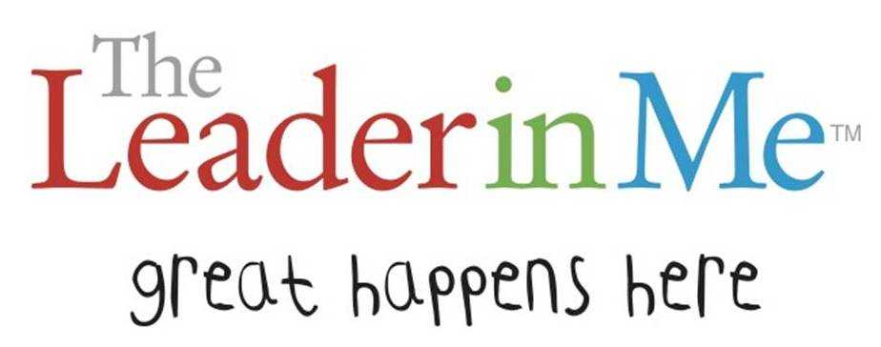

September – Be Proactive
October – Begin with the End in Mind
November/December – Put First Things First
January – Think Win-Win
February – Seek First to Understand, Then to Be Understood
March – Synergize
April –Sharpen the Saw
May – Find Your Voice

